Milestone Report 2

**Introduction:**

To complete our project in a timely and efficient manner, we split it up into multiple milestones. For milestone two, our goal was to create a DC/DC converter that would regulate a varying input voltage and increase its value to a constant DC value of nine volts. The deliverables outlined to be finished by milestone 2 are as follows: a working DC/DC converter with PWM feedback control and completed optimal load testing to determine the ideal load resistor value. Using LTSpice, Excel, some research, and the components included in our kit, we produced the deliverables outlined above.

**High Level Design:**

Shown below is the most recent and up to date version of the entire system presented as a block diagram. The focus of this milestone was to complete the calculations necessary to construct the physical components of the project. The details of this process are discussed in the following sections. 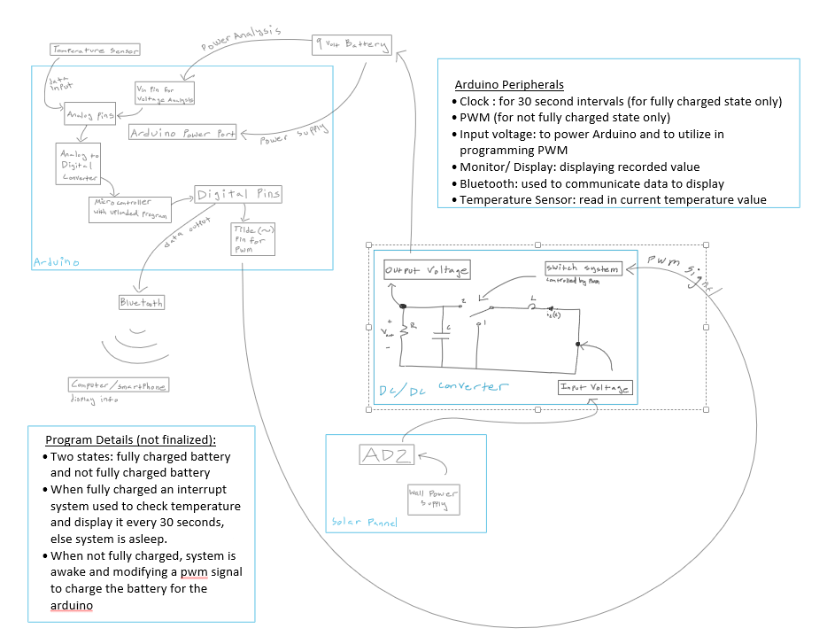

**Detailed Design Components:**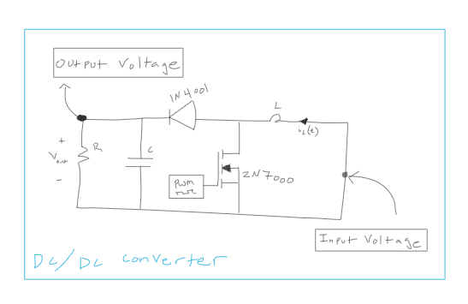

The process for completing this milestone started with preliminary research into what type of converter would suit our project. By referencing Chapter two of “Converters in Equilibrium”, a text reference provided in class, we determined a boost converter was the optimal choice. This decision was made based upon how the boost converter functions. The boost converter is able to increase an input voltage value while a buck converter decreases voltage. The purpose of the converter, as stated in the project description, is to increase an input voltage of approximately five volts to a DC output voltage of nine volts. Thus the boost converter is the only choice between the two that is capable of achieving the desired result. A buck boost converter was not considered as it reverses the polarity of the signal and is more complicated than a buck or boost converter. The block diagram of the DC/DC converter is pictured above.

Once the type of converter was selected, in order to meet our goal for this milestone, calculating or selecting values of all of the needed components was necessary. To calculate the values of the inductor and the capacitor, we assumed a PWM frequency of 5.5kHz. This value was selected because it is higher than the minimum frequency value required by the project description, and is able to be produced by the Arduino. We then assumed a value of 1.5kΩ for our resistor, based on the minimum value outlined in the project description and the resistors available in our kit. Once we had these values, we were able to calculate the inductor and capacitor values. These calculations are seen below: 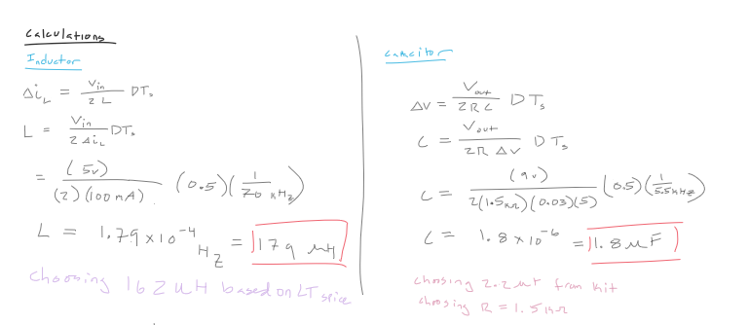

As you can see, the frequency in the inductor calculation is different from that in the capacitor. The reason for this lies in the LTSpice simulation. We initially calculated the inductor value with the frequency of 5.5kHz, and derived the resulting value of 0.0108 Henries. Putting the calculated values into our LTSpice circuit the following graph was produced: 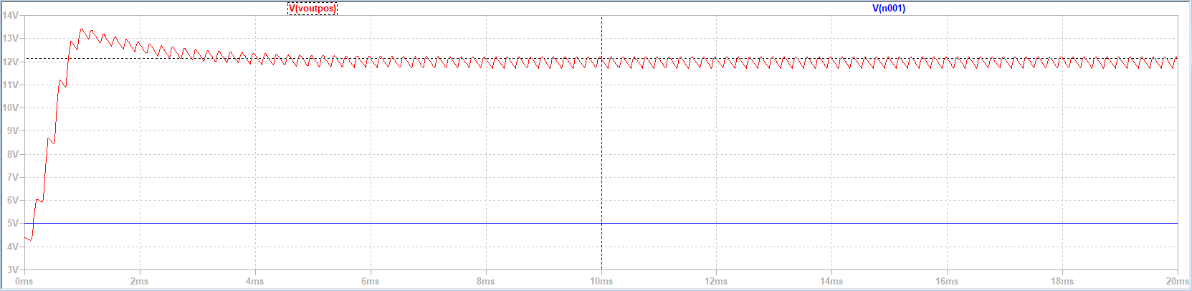

As seen in the graph above, the output voltage value is much higher than the voltage necessary to complete the goals outlined in the project description. The value of the inductor was greatly reduced, and some new calculations were conducted, until a value of 179μH was found. This value was further refined to 162μH and the graph resulting from this new value can be seen below: 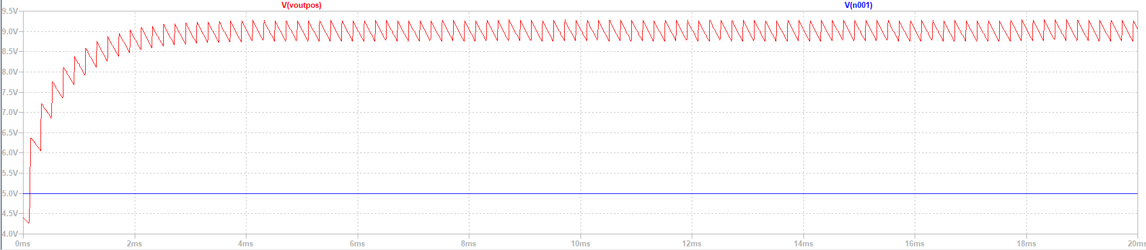

The other deliverable for this milestone was the optimal load test. Using our calculated values from our equations, we were able to create an optimal load waveform. The first step of this process was to determine the resistance of the system ($R_{s}$). The calculations used to determine this value are shown below: 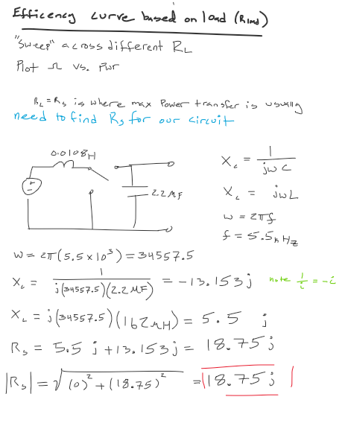

Once the value of $R_{s}$ was calculated the power of the system depending on the value of the Load resistor was calculated for all resistor values ranging from zero to 1.6Ω. This was done using excel and the formula below: 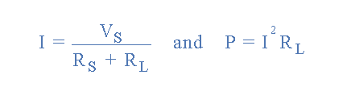

The follow graph was generated from these calculated values, with approximately 1.5kΩ as the peak: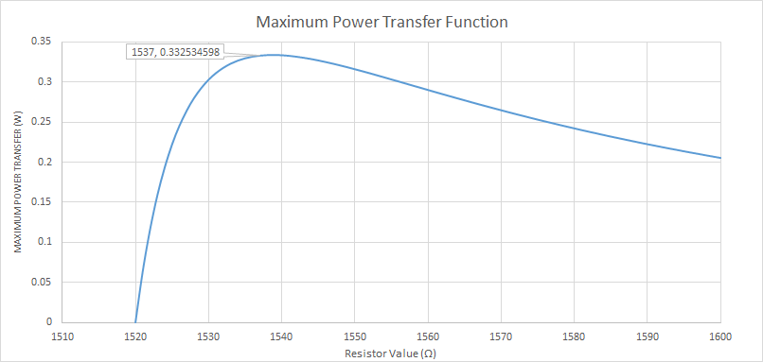

Included below is the circuit constructed in LTSpice that was utilized for the above simulations: 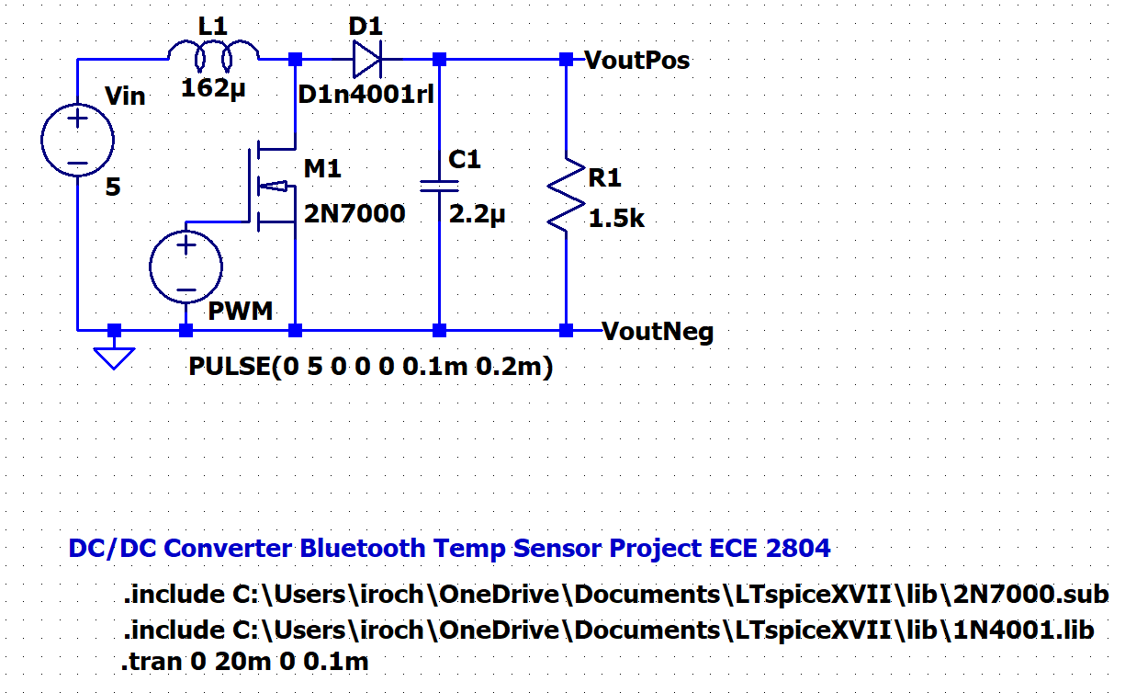

**Validation:**

As noted in the previous section, the calculated value of the inductance was not adequately matched with the desired output results. The issue was swiftly resolved by rotating through different possible frequencies and values until eventually the desired result was achieved and the selected components were easily accessible from either our kits or the provided supplies for the project. There may also be some issues within the optimum load test that have yet to be addressed, however those will be further discussed and resolved by the completion of the next milestone.

All of the goals outlined for this milestone were aptly completed. The needed calculations were conducted and a working circuit was designed and simulated in LTSpice. Further, the optimal load test was conducted and the ideal load resistor value was determined.

**Conclusion:**

Through milestone 2, we learned about how to conduct a steady state converter analysis of a DC/DC boost converter. We also learned more about the role of frequency, inductance, capacitance, and resistance in the output of DC/DC converters. Furthermore, through the milestone, we were taught about how to create a system that passes an optimal load test as well as how to conduct an optimal load test. Overall, we learned about how to design a system using limited initial conditions in order to produce waveforms that match our desired result.